* Why would I want to write type script vs traditional javascript
* 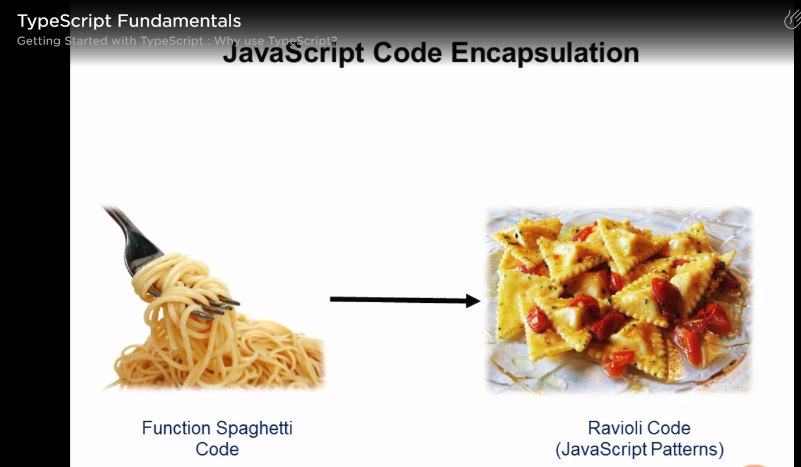
* Need expertise and learning to write modularized code in javascript where as type script has facilities of OOPs to write modularized code with ease.
* 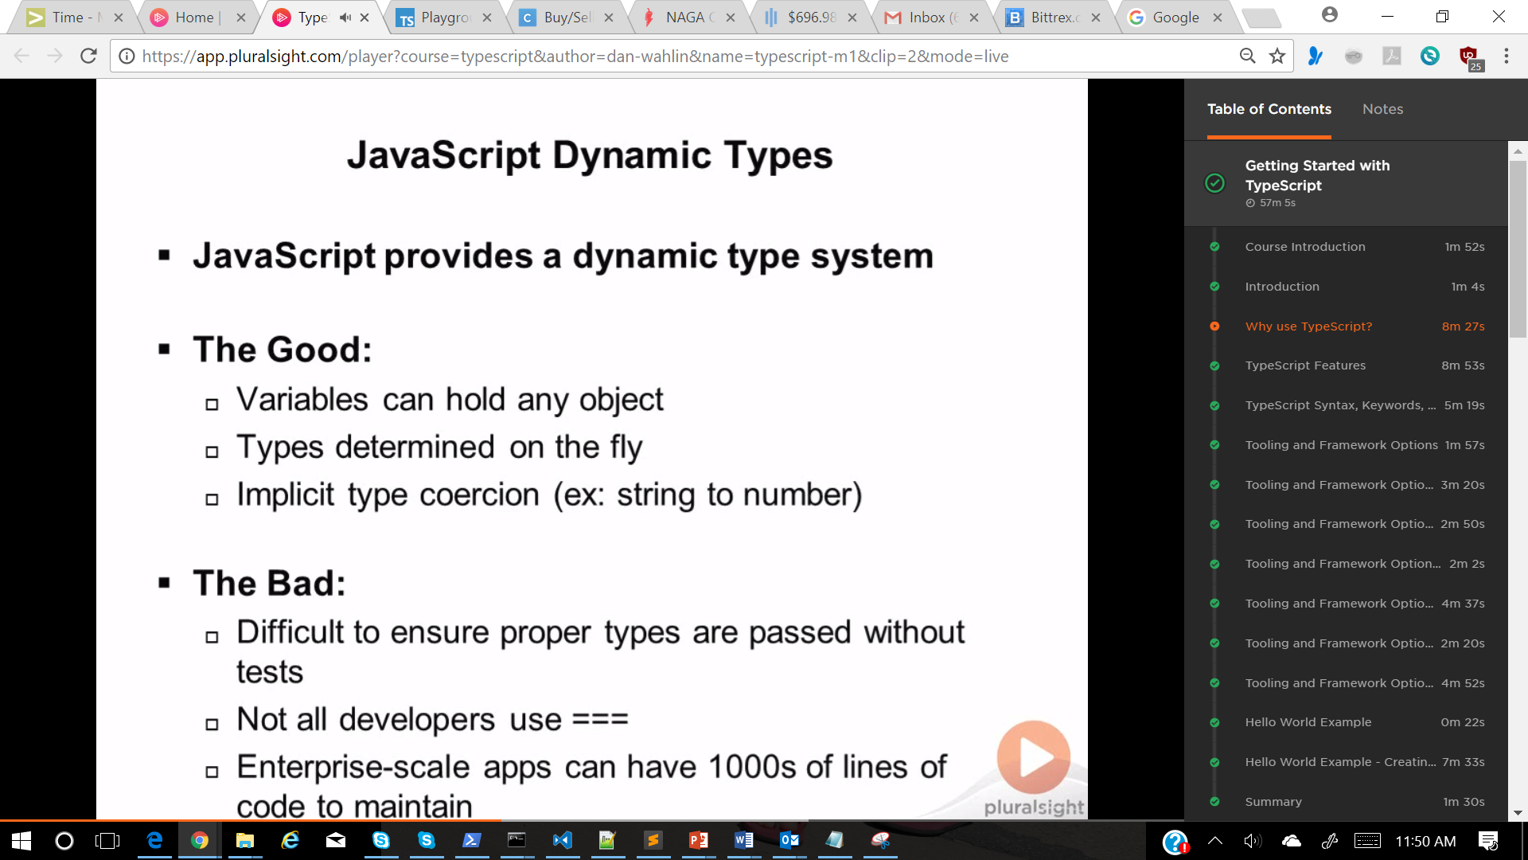
* Type conversions
  + <http://2ality.com/2013/04/quirk-implicit-conversion.html>
  + <https://www.w3schools.com/js/js_type_conversion.asp>

JavaScript Data Types

In JavaScript there are 5 different data types that can contain values:

* string
* number
* boolean
* object
* function

There are 3 types of objects:

* Object
* Date
* Array

And 2 data types that cannot contain values:

1. null
2. undefined

* typeof "John"                 // Returns "string"   
  typeof 3.14                   // Returns "number"  
  typeof NaN                    // Returns "number"  
  typeof false                  // Returns "boolean"  
  typeof [1,2,3,4]              // Returns "object"  
  typeof {name:'John', age:34}  // Returns "object"  
  typeof new Date()             // Returns "object"  
  typeof function () {}         // Returns "function"  
  typeof myCar                  // Returns "undefined" \*  
  typeof null                   // Returns "object"
* There are other options parallel to typescript.

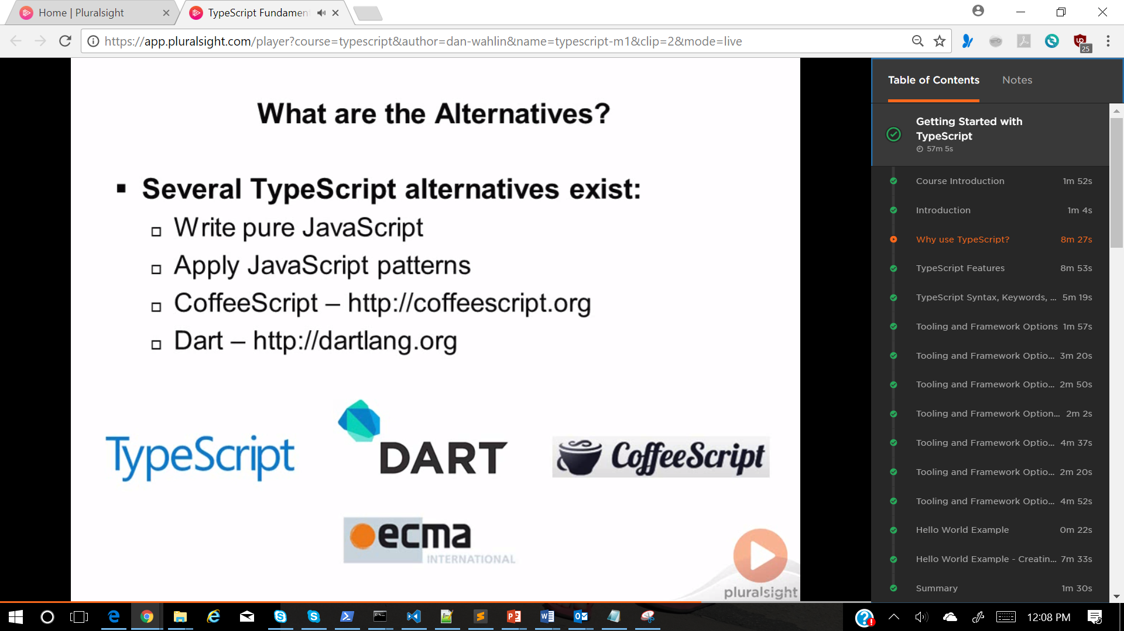

* Type script is a layer on top of javascript just like any other language
* 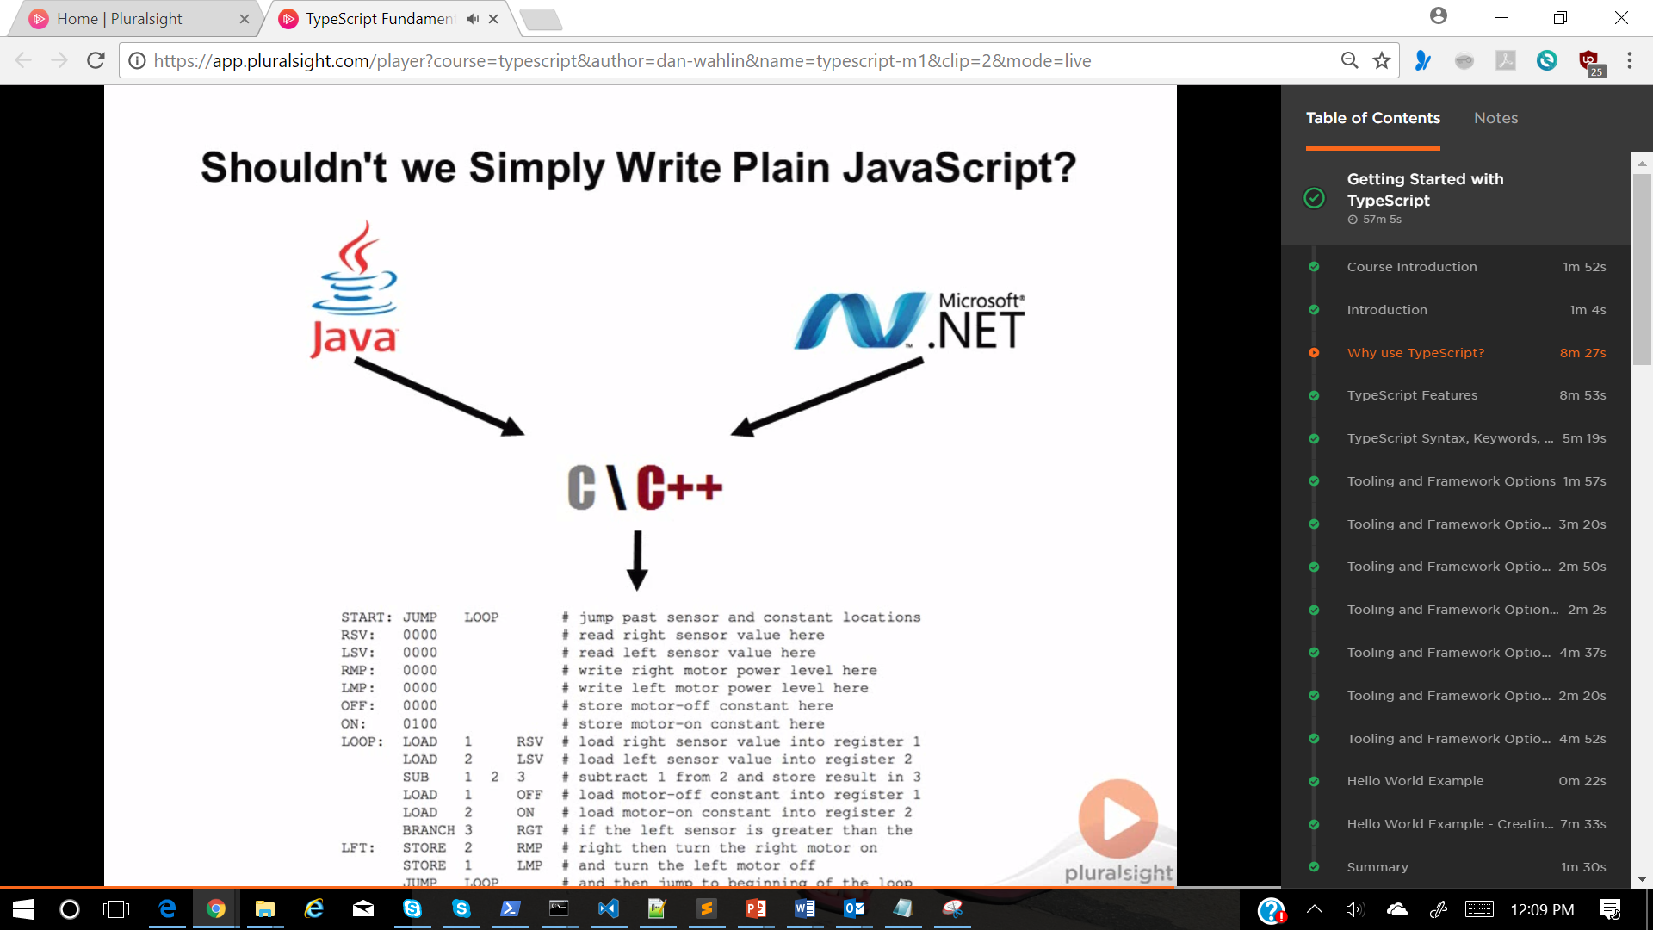

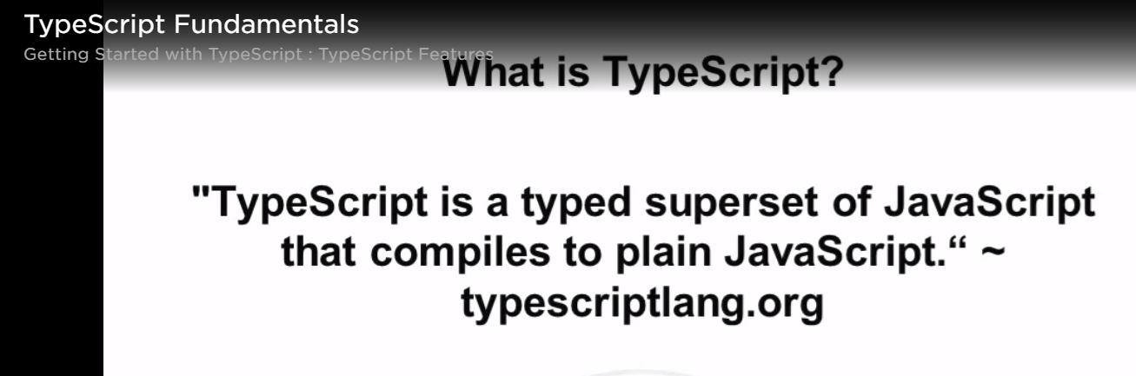

* Tool support is very good and that makes typescript stand out compared to others like DART, coffee script, ECMA ?

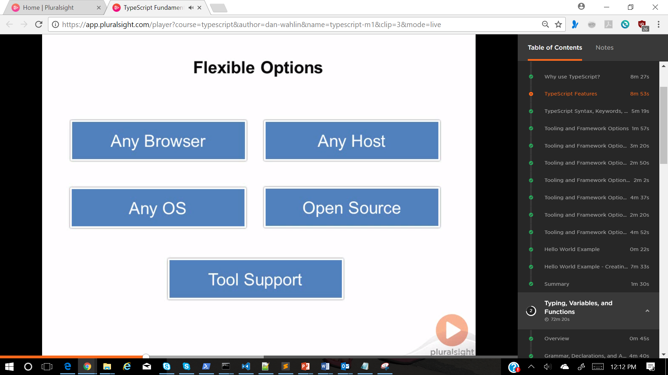

-

- Typescript provides below features which are not in javascript specially OOPs, interfaces and lambda for call backs Etc.

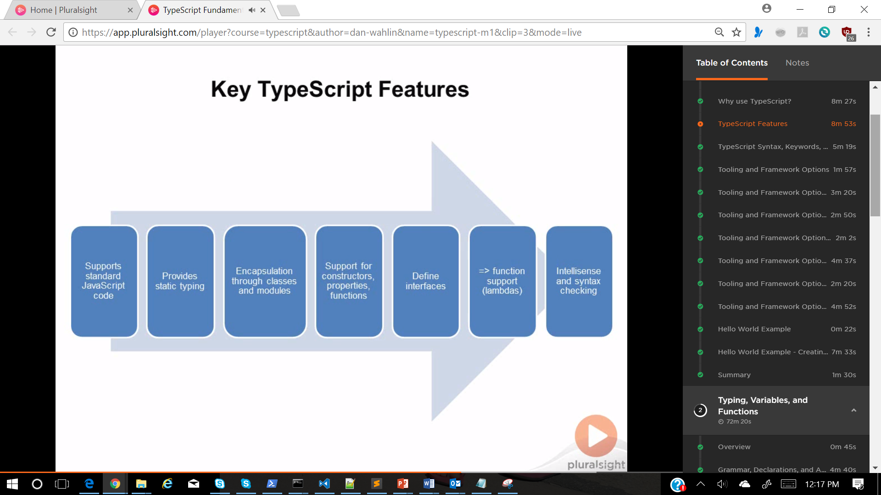

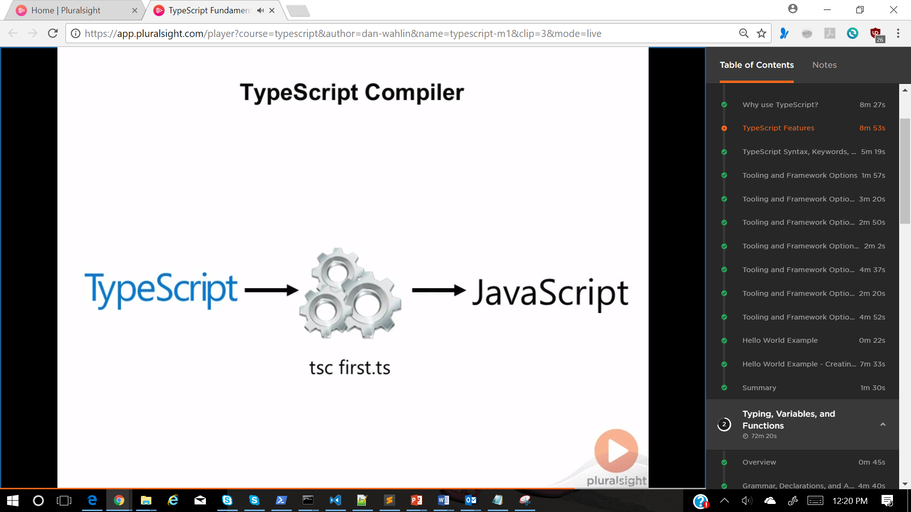

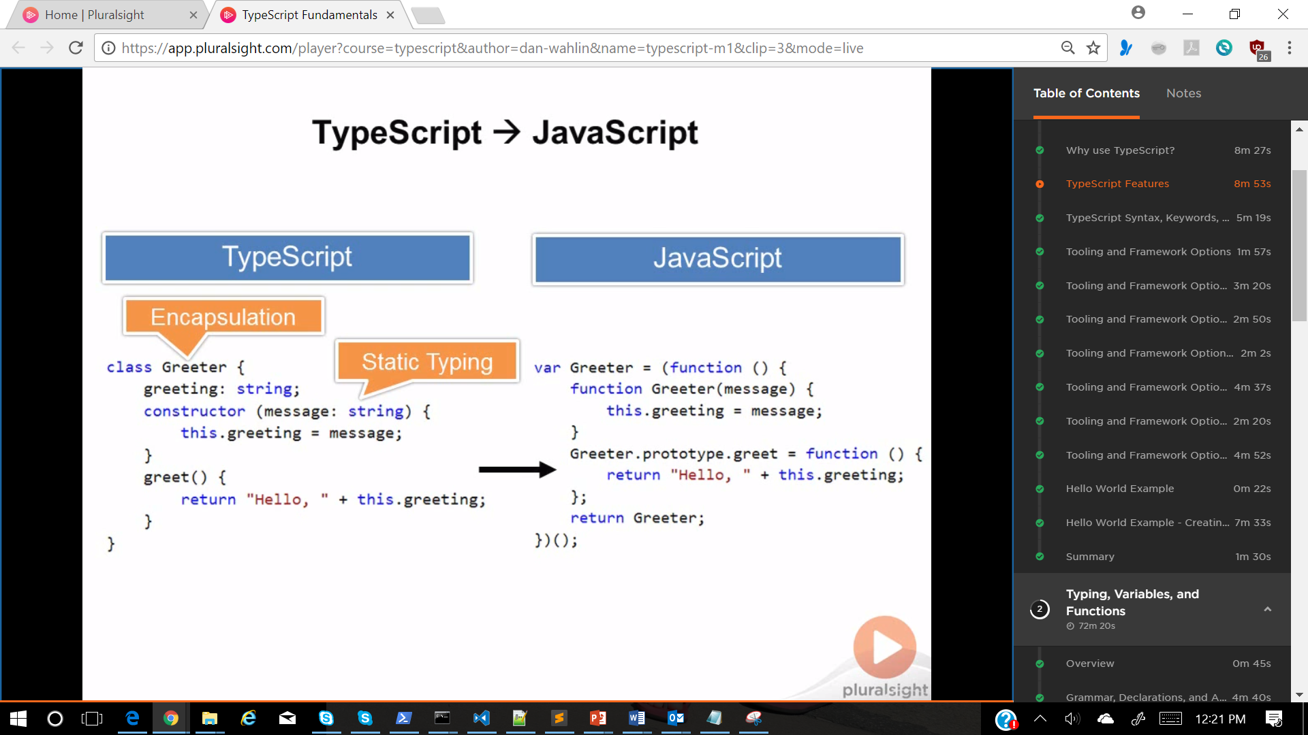

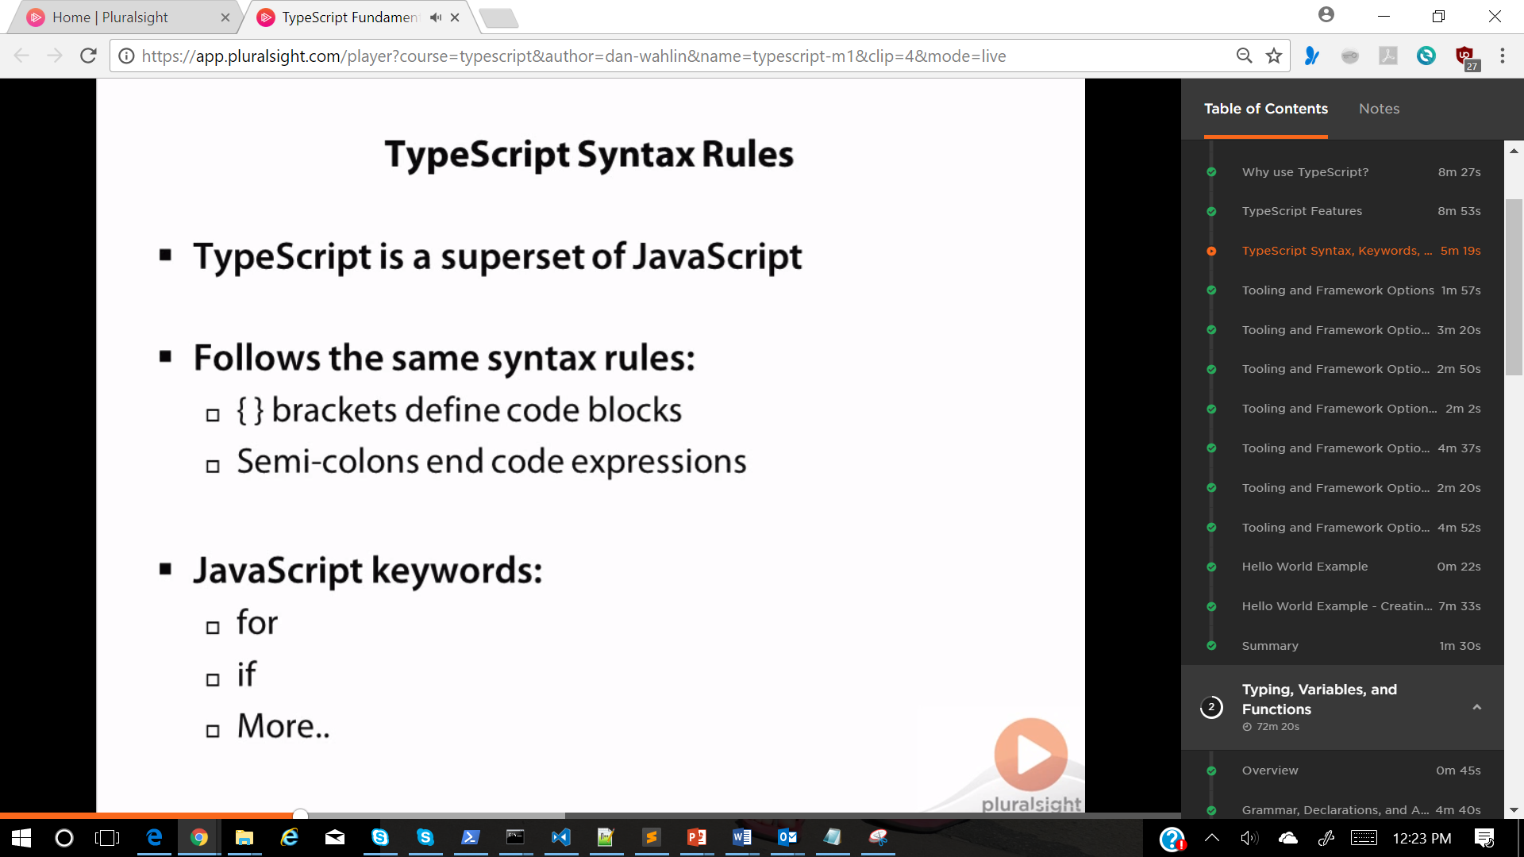

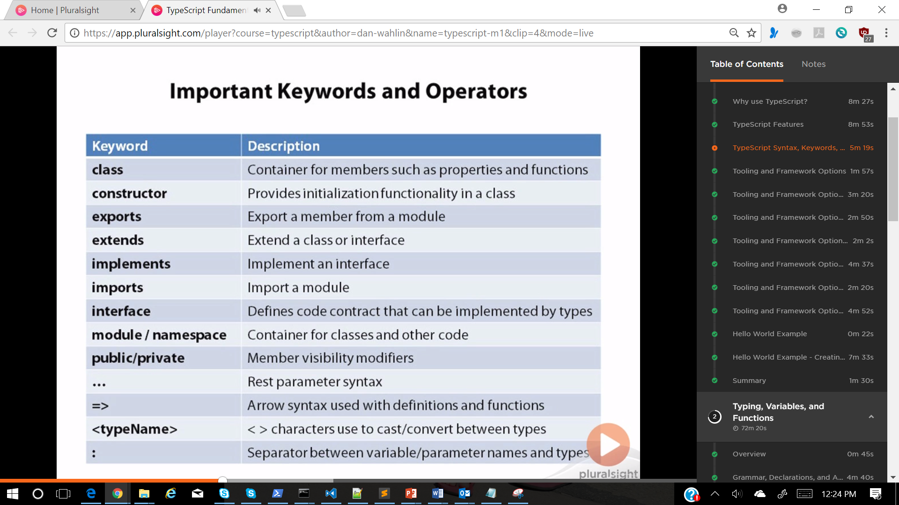

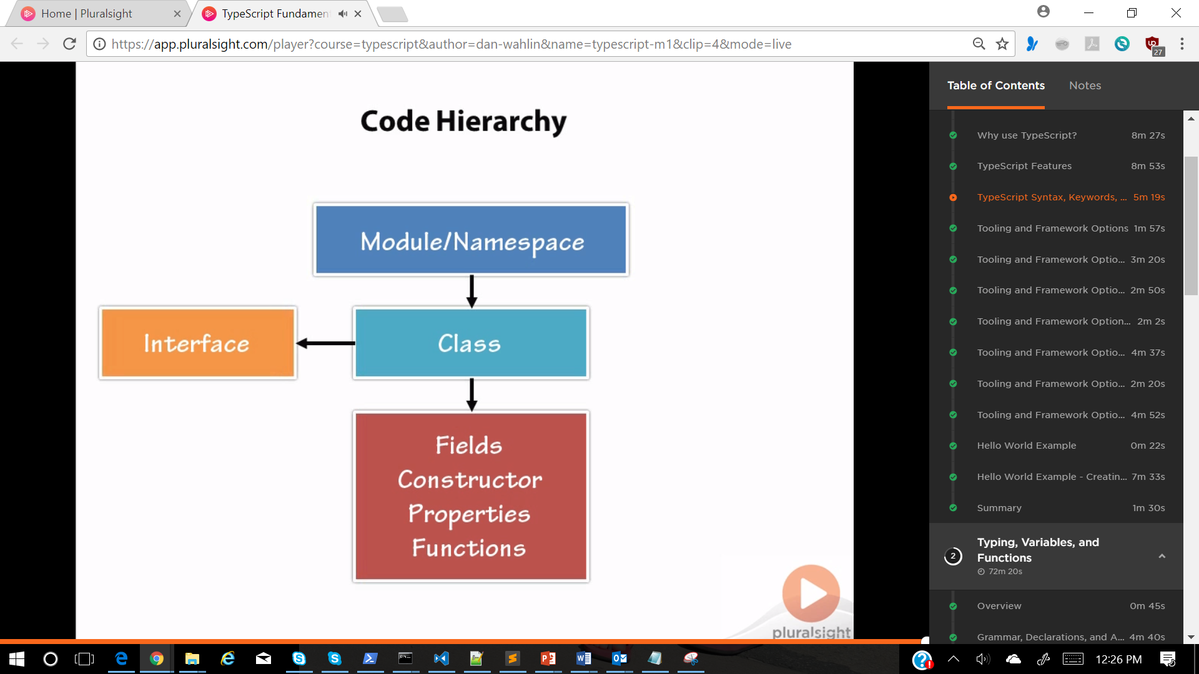

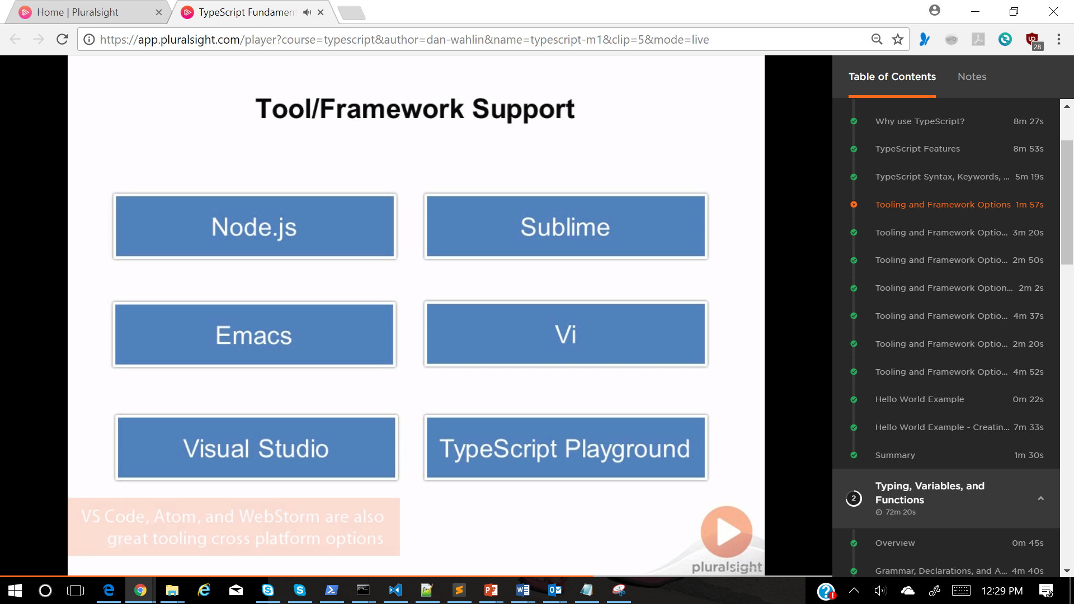

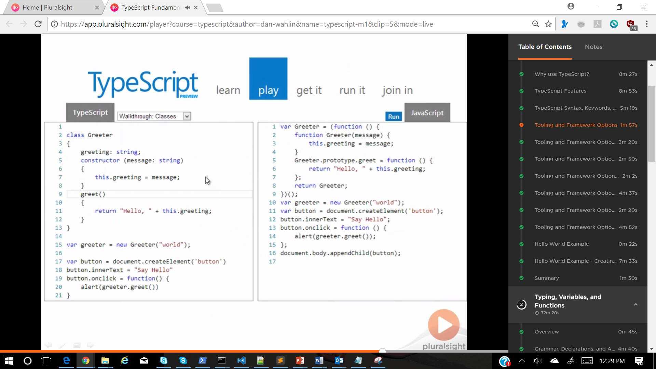

TOOLING SUPPORT

1. Typescript playground
   1. <https://www.typescriptlang.org/play/index.html>
2. Visual studio
   1. Open a new empty project and add a typescript file
   2. 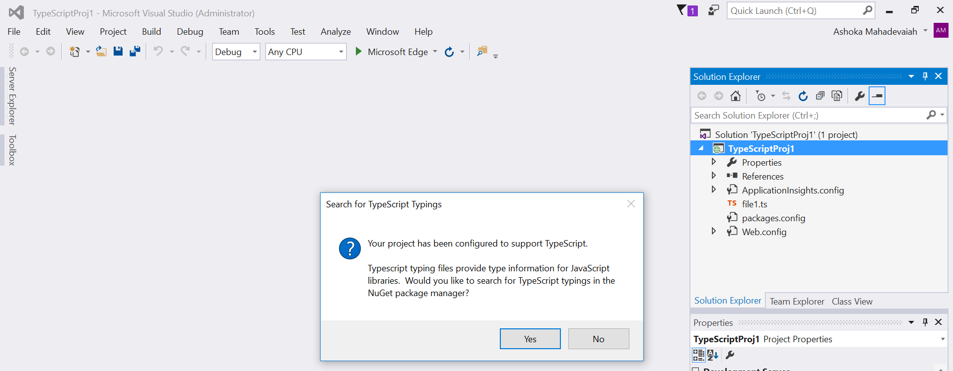
   3. 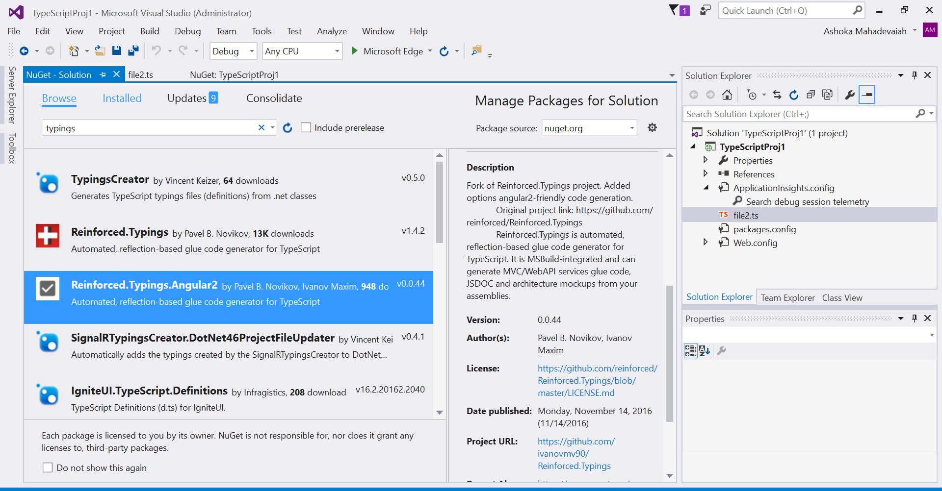
   4. Install Typing package for visual studio
   5. 
   6. 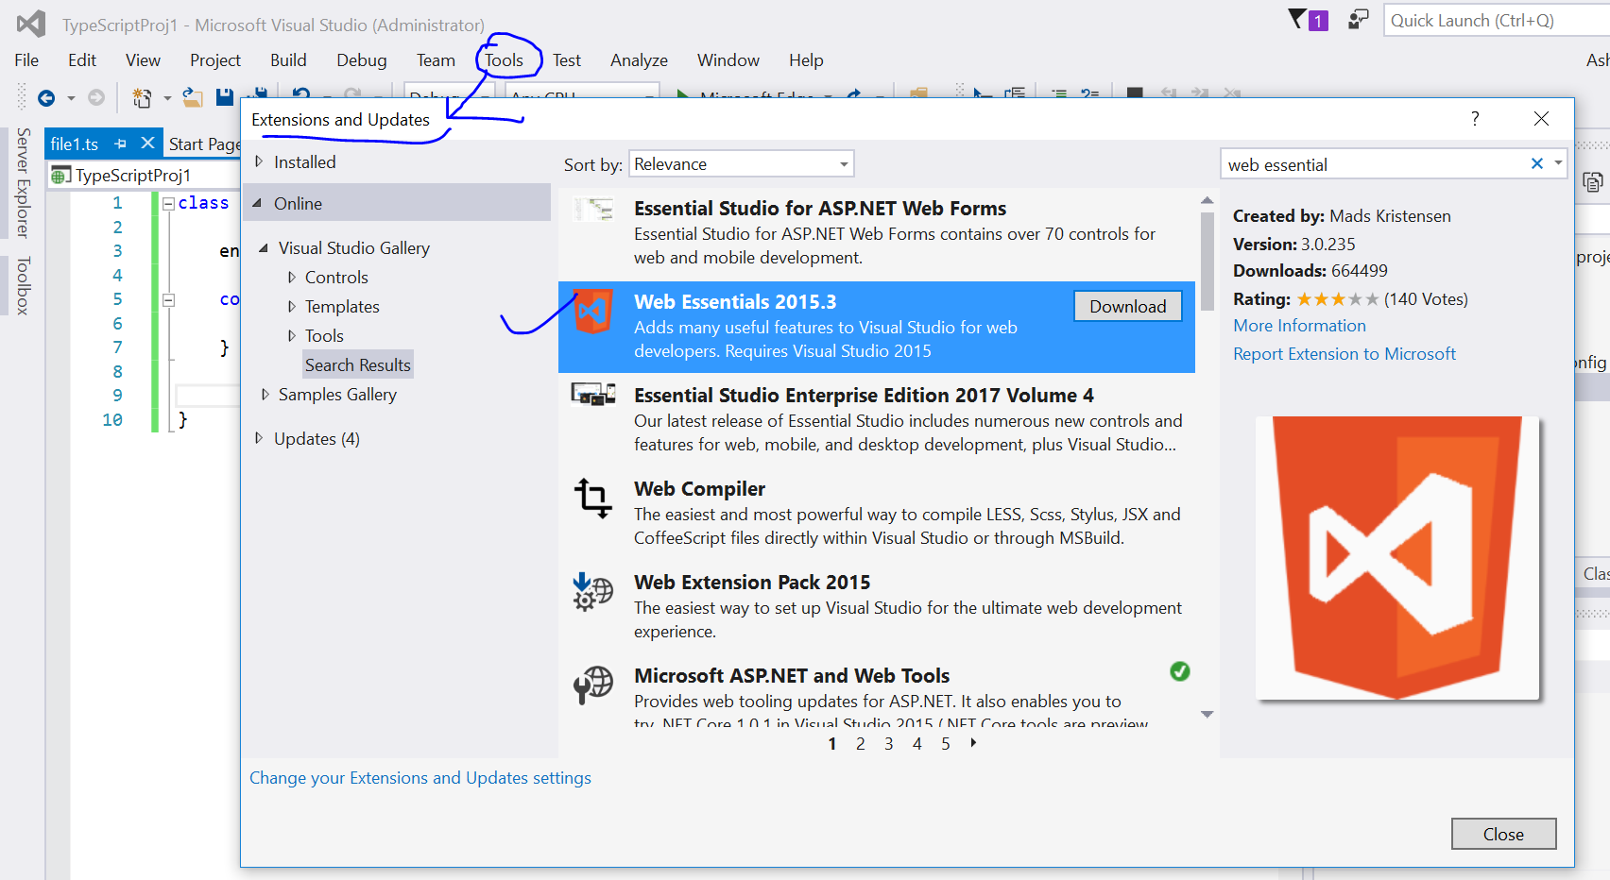
   7. 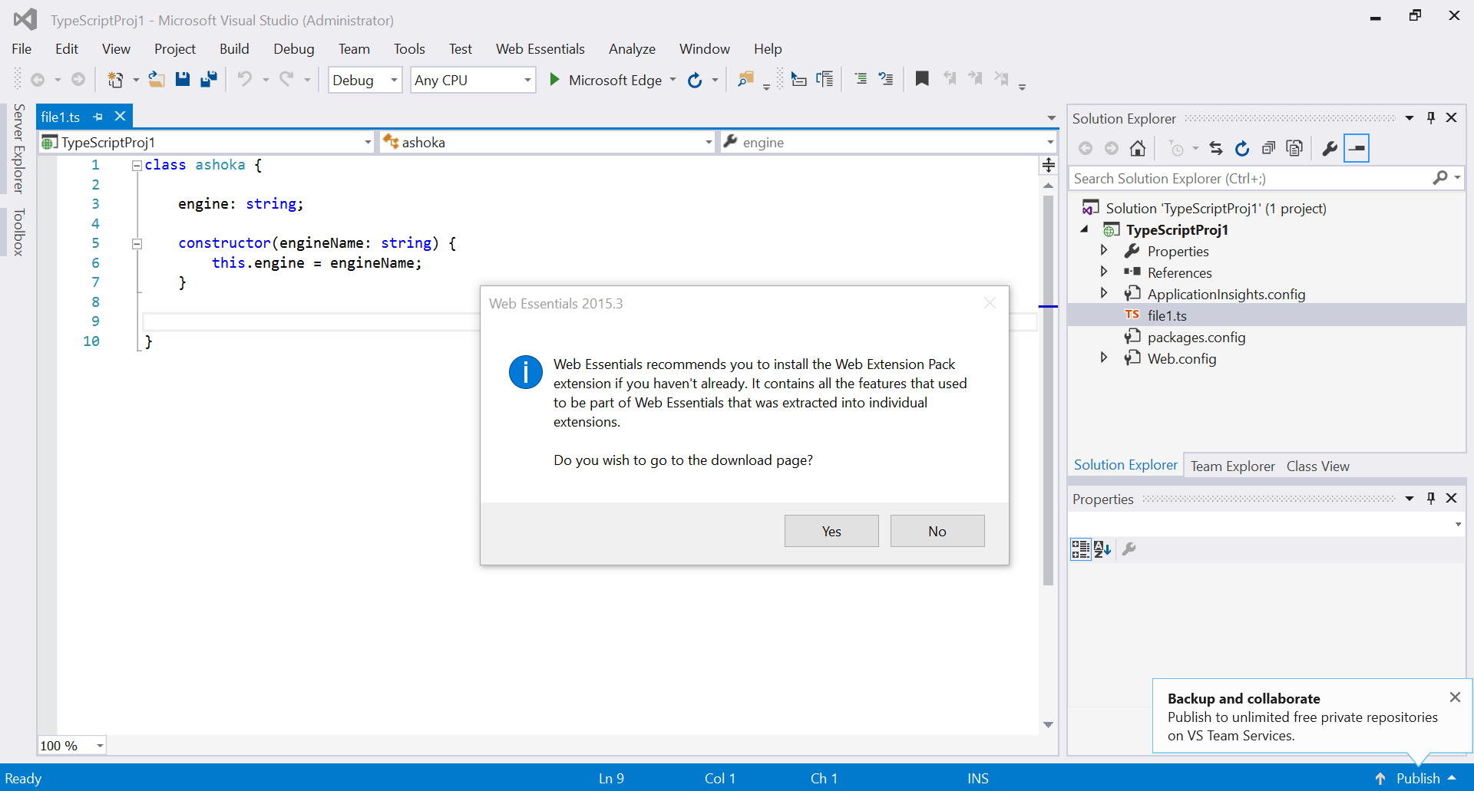
   8. 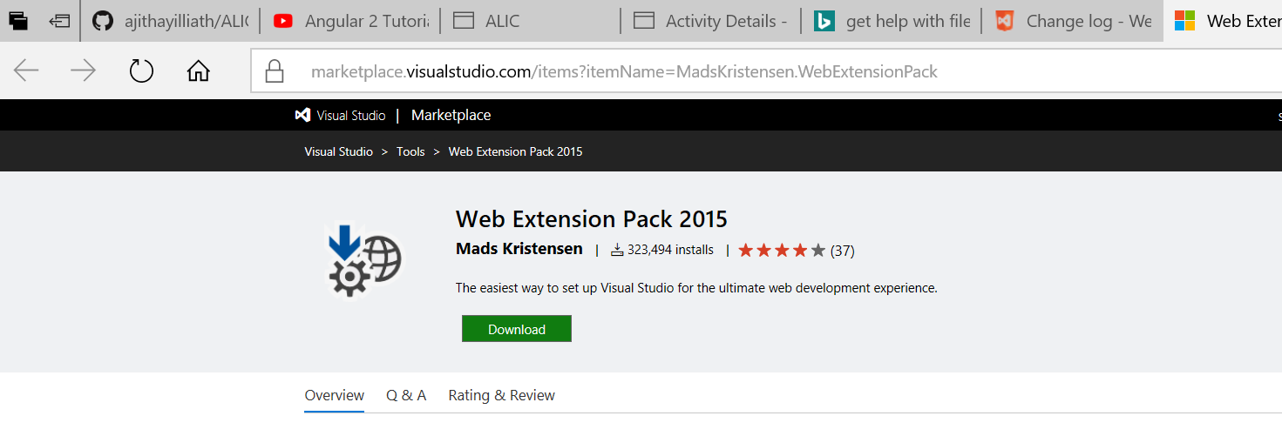
   9. 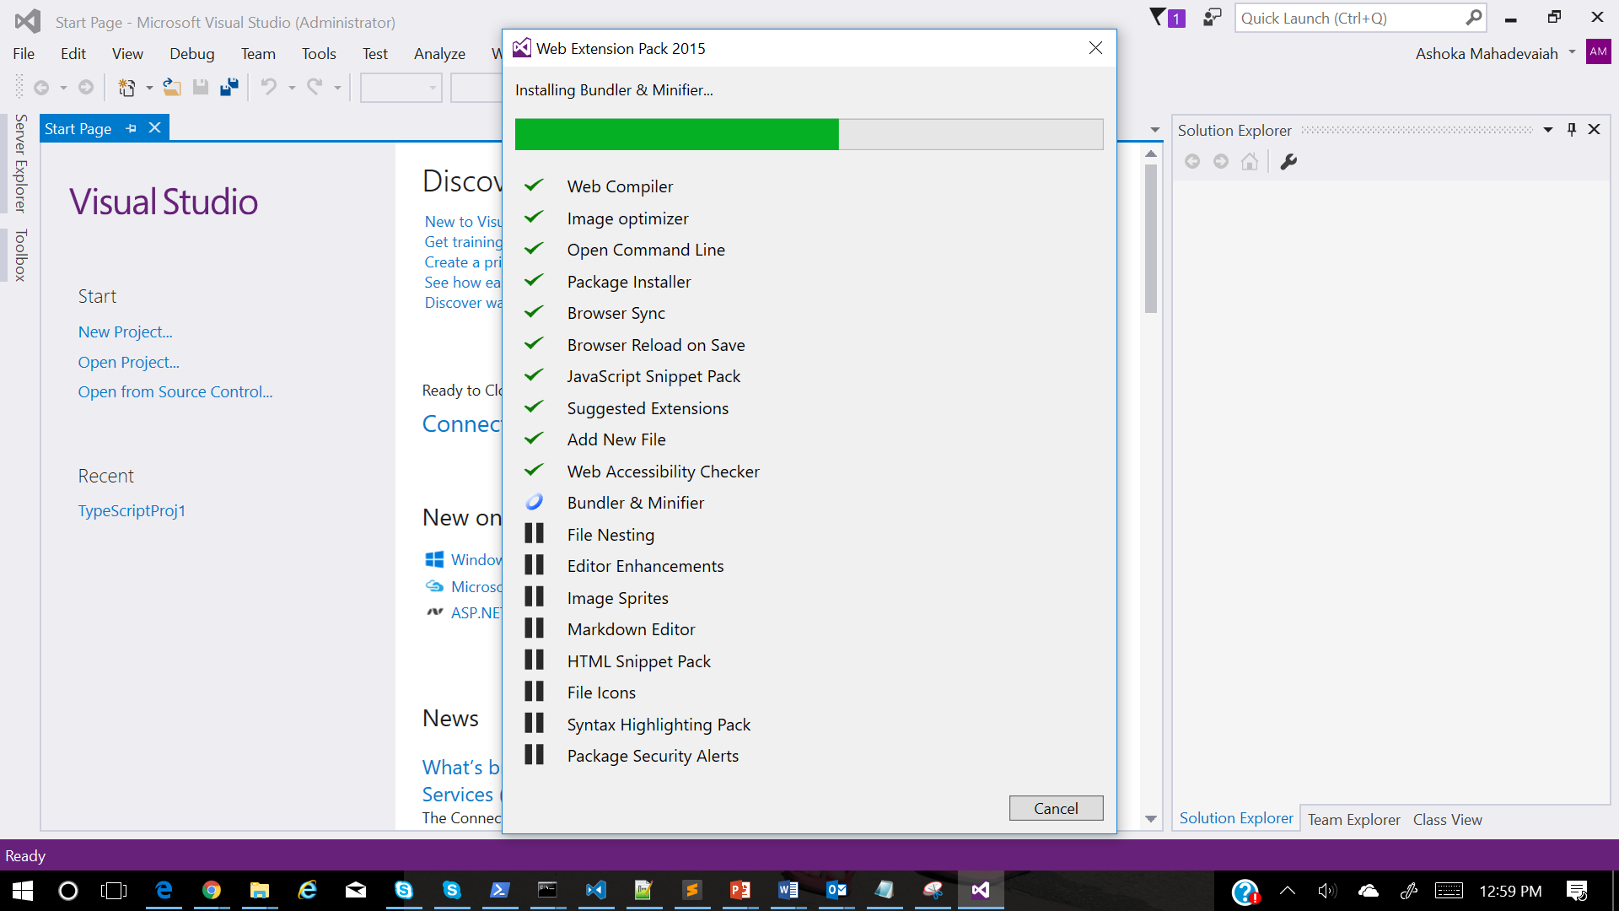
3. Command line compilation
   1. 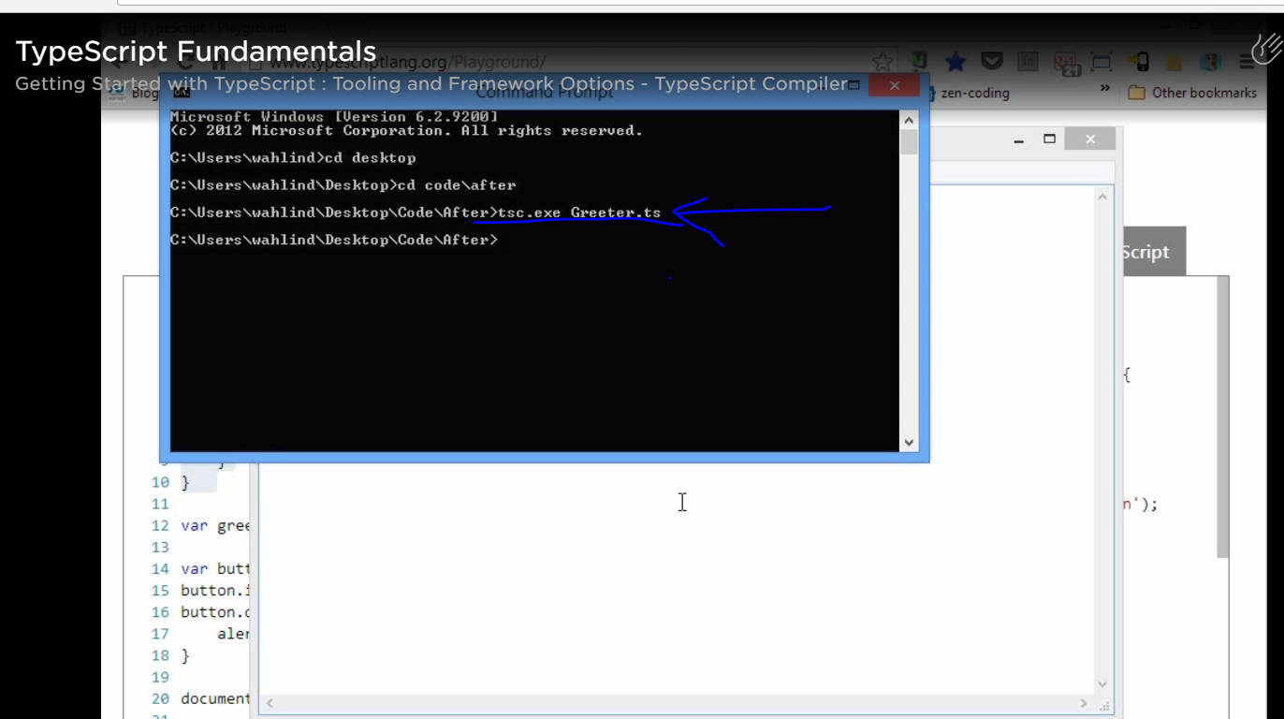
   2. 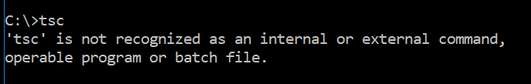
   3. 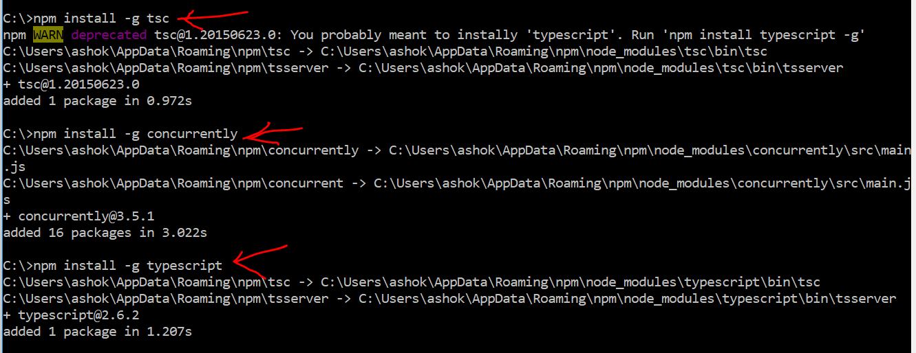
   4. 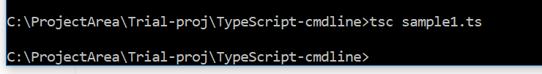
   5. 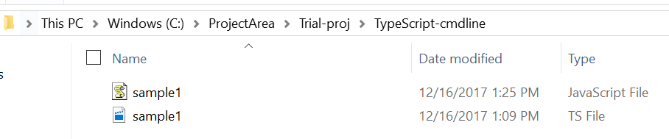
4. Hello world example
   1. 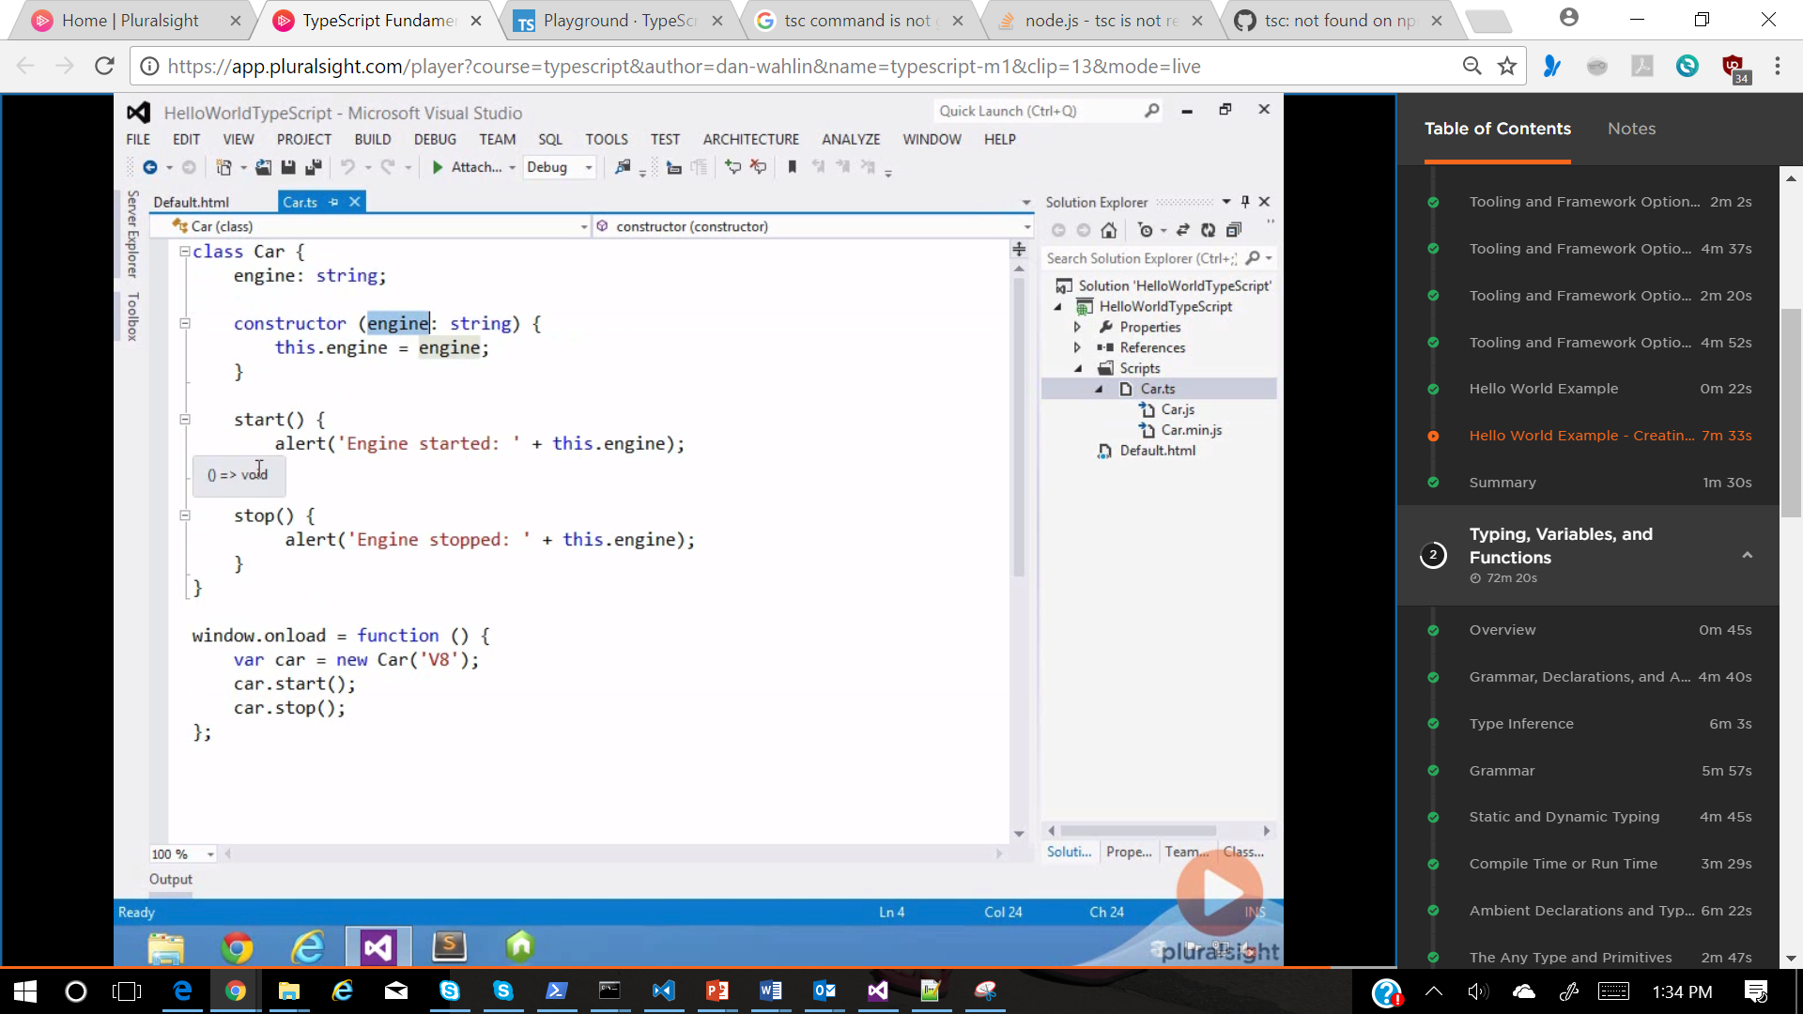
   2. 